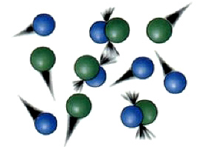**Reaction Rate (Pearson 1.1)**

**Measuring Reaction Rates**

The reaction rate can be determined by measuring the rate of depletion of reagents or the rate of formation of products over time.

Direct or indirect measurable quantities include:

* mass/volume of reagent lost or product gained
* changes in the intensity of colour
* solution pH
* temperature
* solution concentration or gas pressure

Each of these needs to be measured per unit of time.

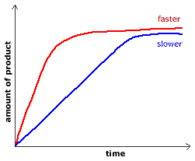**Plotting Reaction Rate**

* Plotting the quantity measured vs time produces a reaction rate graph.
* The slope of the line reflects the rate of the reaction at that time.
* A fast reaction will have a steeper slope than a slower reaction.
* A horizontal line indicates the reaction has stopped or reached a point of equilibrium.

**Collision Theory**

**Assumptions for a reaction to occur:**

1. Particles must collide.
2. 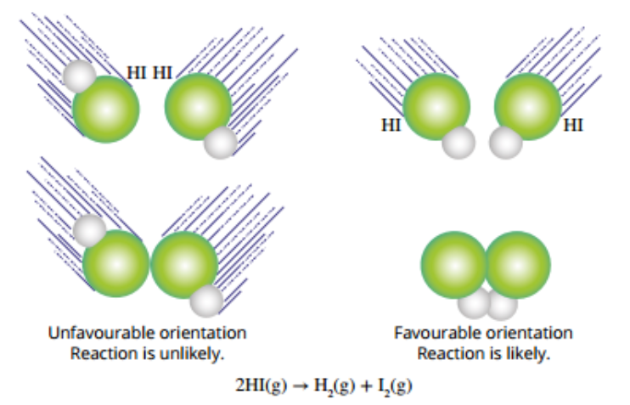Particles must collide with the correct orientation
   * Collision orientation must allow breaking of bonds and formation of new bonds.
   * If the orientation is incorrect the particles will bounce off each other and no reaction will occur.
   * Collision orientation is random and therefore something that can not be controlled.
3. Must collide with sufficient energy.
   * Even if particles collide with the correct orientation, they must collide with sufficient energy to break the bonds.
   * If the particles do not collide with sufficient energy they will bounce off each other and no reaction will occur.

**Energy and Reaction Rate**

**Basic Idea’s**

* Moving particles contain kinetic energy according to the equation EK = ½.m.v2, therefore the faster the particles the higher the kinetic energy.
* At any given temperature, an object will consist of particles with a wide range of velocities and therefore kinetic energies.
* Temperature is defined as the average kinetic energy of a objects particles.
* The amount of kinetic energy required for a reaction to occur is called the activation energy Ea)
* Two graphs are commonly when considering energy and reaction rate. These are the Maxwell Boltzen Distribution and the Energy Profile.

The **Maxwell–Boltzmann distribution** is a probability distribution named after [James Clerk Maxwell](https://en.wikipedia.org/wiki/James_Clerk_Maxwell) and [Ludwig Boltzmann](https://en.wikipedia.org/wiki/Ludwig_Boltzmann).

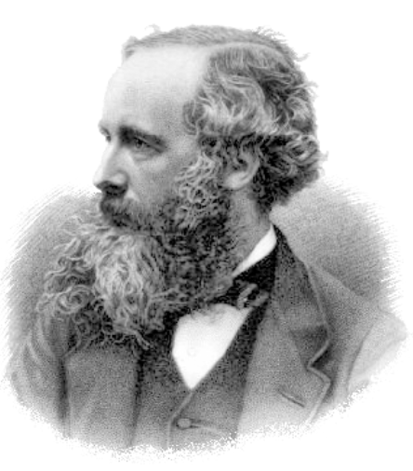

**The Maxwell Boltzen Distribution**

* The Maxell Boltzen distribution is a graph that shows the spread of kinetic energy for an object at a particular temperature.
* If the activation energy. Ea of a reaction is known the graph can also show the proportion of particles that have sufficient activation energy for a reaction to occur.
* For example, in the diagram below the shaded areas under the graph represent the proportion of particles with sufficient energy to react. The graph shows how there are a greater proportion of particles with the required energy at 30oC than 20oC. Therefore the reaction rate will be faster at 30oC.

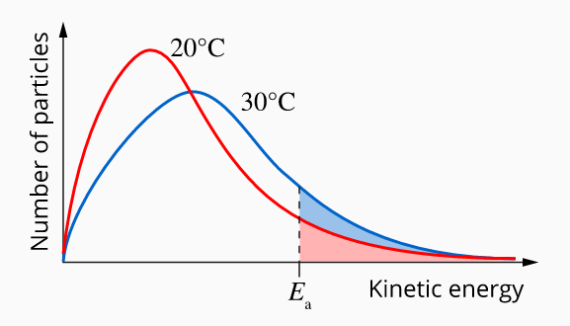

**The Energy Distribution Diagram**

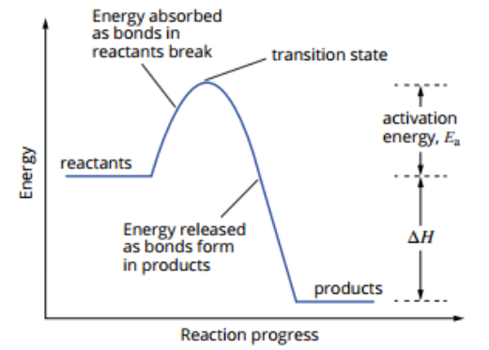

The energy distribution diagram is a graph that shows the energy of the substances as the reaction progresses.

**Enthalpy**

Enthalpy (H) is the internal energy of a system.

It shows the following:

* The energy (enthalpy) of the reactants
* The energy (enthalpy) of the products
* The energy required for the reaction to occur (the activation energy, Ea).
* The change in energy during the reaction (the enthalpy change, ΔH)

Other Important Points

* Energy is required to break bonds, energy is released as bonds are formed
* The transition state represents the point where the bonds of the reactants have been broken but the bonds of the products have not yet formed.
* The activation energy, Ea for the reverse reaction (products to reactants) is the sum of the ΔH and Ea of the forward direction.

**Endothermic vs Exothermic Reactions**

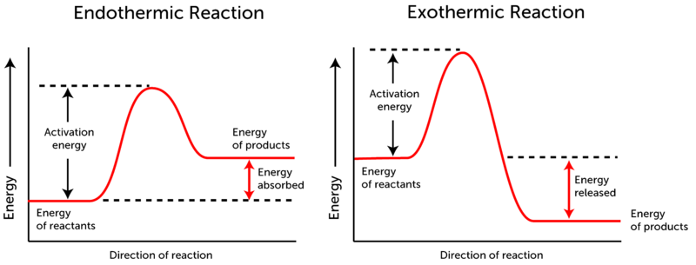

**Endothermic reactions.**

* The energy absorbed during bond breaking is larger than the energy released during bond formation.
* The overall change in energy (the enthalpy change, ΔH) is positive
* Energy is absorbed during the reaction.

**Exothermic reactions.**

* The energy absorbed during bond breaking is smaller than the energy released during bond formation.
* The overall change in energy (the enthalpy change, ΔH) is negative
* Energy is released during the reaction.

**Maxwell–Boltzmann distribution (more detail)**

* 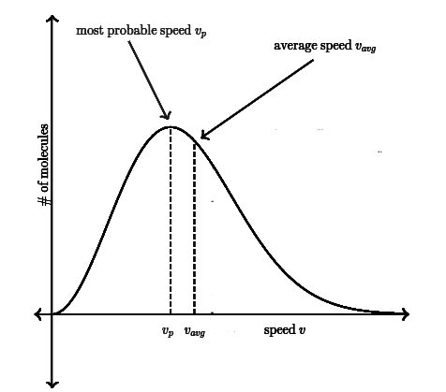The highest point represents the kinetic energy that occurs the most (the mode)

The average

The mode

* The average kinetic energy is to the right of this peak

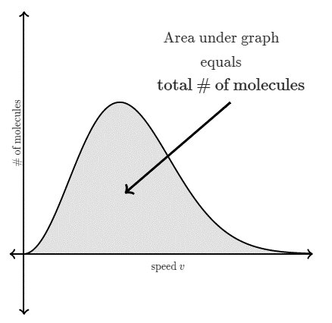

The area under curve = total number of particles

* The area under the curve is the total number of particles

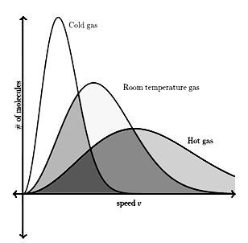

Cold gas

* As the temperature of a substance, increases since the area under the curve remains the same the height of the curve will decrease.

Hot gas

Room temp gas